**VCS Task**

Establish a new directory, populate it with script files, initiate an empty repository on GitHub, convert the local directory into a Git repository, and link it to GitHub for pushing the code into the repository.Perform merge, rebase, stash commands in following github repo.

**Create a New Directory and Populate with Script Files** Open your terminal or command prompt.Navigate to the location where you want to create your new director Create a new directory Add script files to the directory

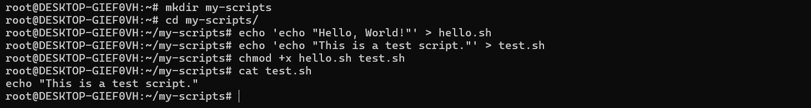

**Create an Empty Repository on GitHub Log in to your GitHub account.**

**Click on the **"New Repository"** button Fill in: **Repository name**: my-scripts **Description**  ,A repository for practicing Git commands **Visibility,** Public or Private Do not initialize with a README.**

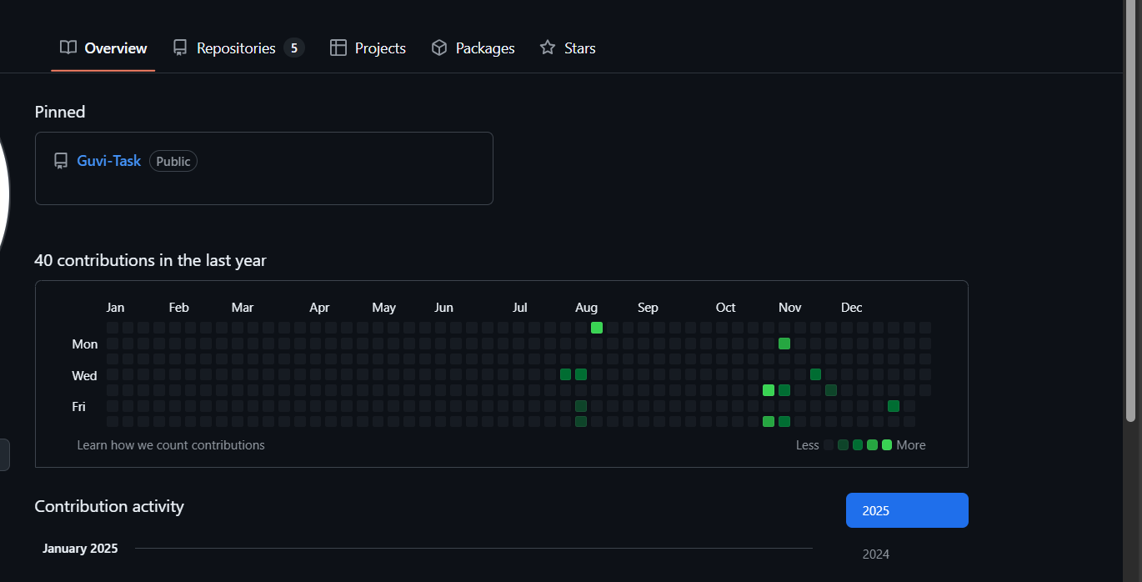

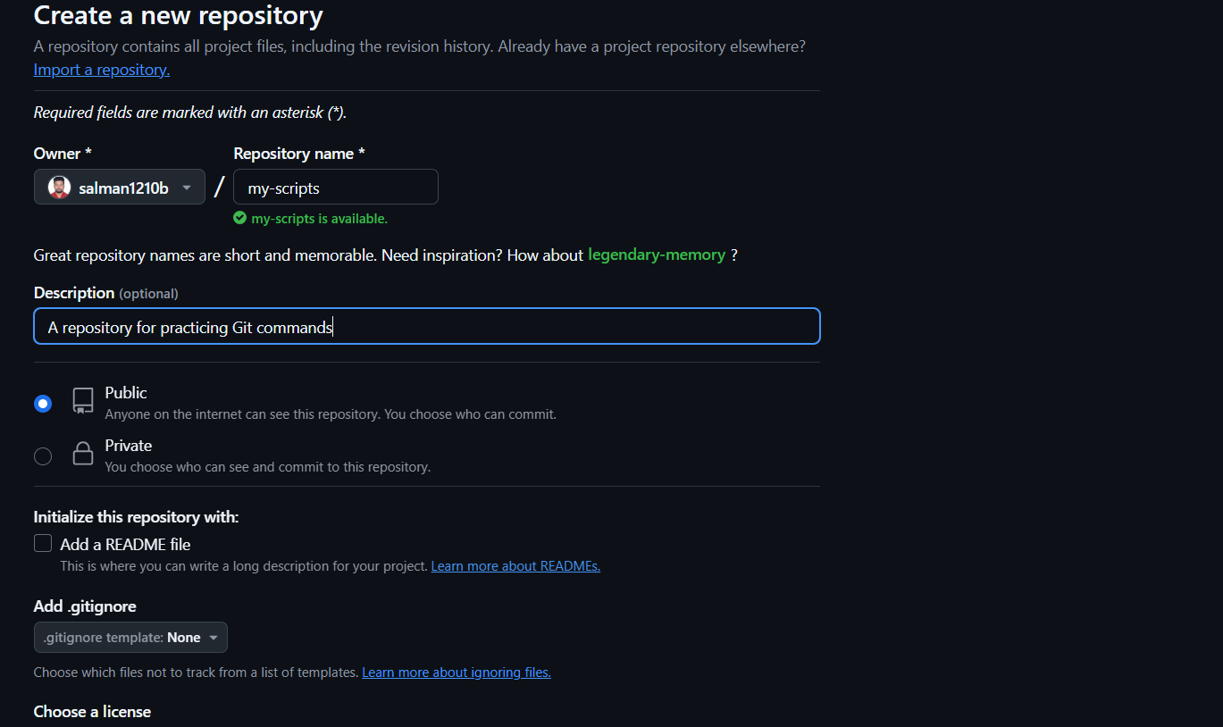

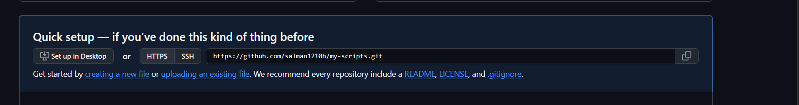

### ****Convert Local Directory into a Git Repository**** Initialize Git in the local directory , Add script files to the repository Commit the changes

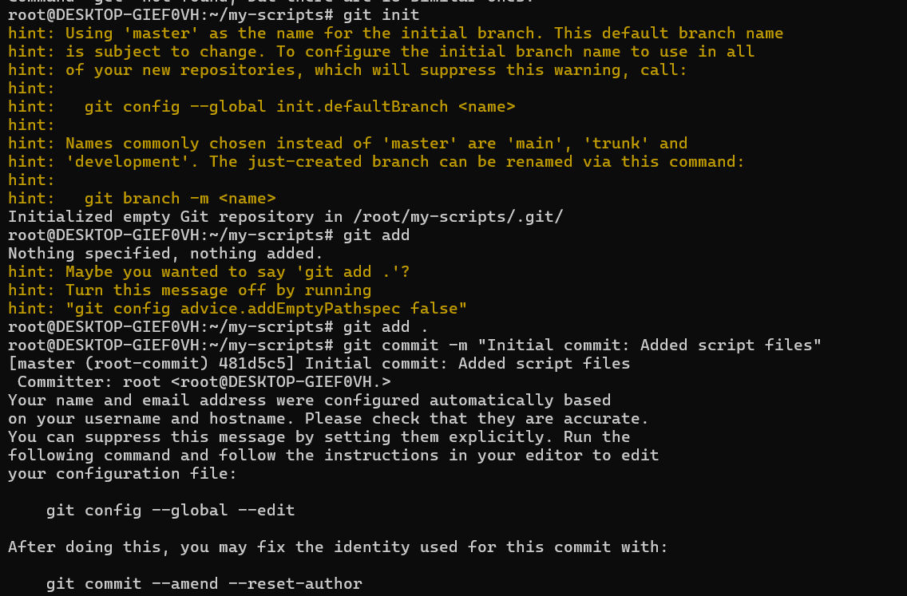

Link Local Repository to GitHub Add the GitHub repository as a remote Push the code to GitHub

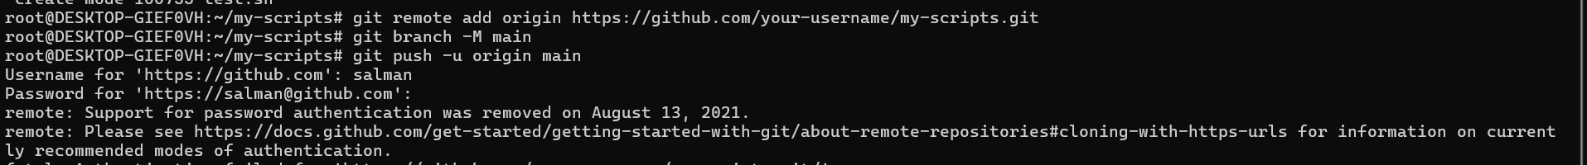

Merge Create a new branch Switch back to main and merge

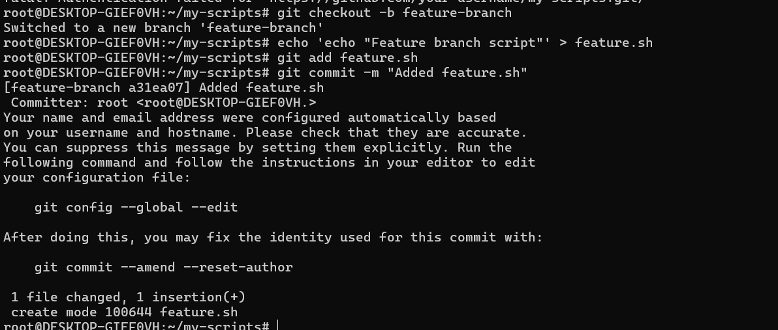

Rebase Reset the branch setup , Rebase feature-branch onto main , Push changes with force Stash Modify a file without committing Save the changes temporarily Apply the stash back

